Directions

**Choose the right milkweed**

Thank you for helping the monarch butterfly and many other pollinators by distributing milkweed seeds! It is important to use milkweed that is right for your area of the country. Find out which milkweed grows in your area by checking these three BONAP maps:

* Asclepias tuberosa, Butterfly Weed: <http://bonap.net/MapGallery/County/Asclepias%20tuberosa.png>
* Asclepias speciosa, Showy Milkweed: <http://bonap.net/MapGallery/County/Asclepias%20speciosa.png>
* Asclepias syriaca, Common Milkweed: <http://bonap.net/MapGallery/County/Asclepias%20syriaca.png>

**Obtain your seeds**

Milkweed seeds can be purchased from a vendor in your area or collected from local plants. You can find where to purchase milkweed seeds in bulk on the Xerces website: <https://xerces.org/milkweed-seed-finder/>. Purchased seeds should be stored in a cool, dry place until you are ready to package them.

Alternatively, seeds can be collected in the fall from ripened pods on local milkweed plants. The pods are ripe when they split open with just a small amount of pressure on the seam. Ripe seeds are brown. Pods that are already open, with milkweed bugs inside, are not good to collect because milkweed bugs damage the seeds. Once pods are collected, the seeds should be separated from the coma (white fluff) and laid out to dry. This is a very fun and very messy activity for kids. Once dried, the seeds should be stored in a cool dry place until you are ready to package them. (The fluff can be composted or used to stuff pillows.)

**Make your packets**

Customize your milkweed packets by editing the pages below in this document. There are two packets per page. Put your organization’s name at the top of each packet. Put the source of the seed and the month/year you plan to package the seed on the side of each packet. Once your seed packets are customized, print out the pages with the milkweed varieties you intend to use. Then simply cut along the dotted lines and fold into packets. Use a tiny amount of non-toxic white or clear school glue to seal the bottom and side of the packet. This is a fun activity for kids. Allow those two sides to dry completely. Do not fill with seeds until the glue is dry on these two sides.

**Fill your customized packets**

Fill your packets from the top with about 20-25 seeds in each packet. You can use more or less depending on which variety of seed you choose and how much seed you have. Use your judgement. Once the seeds have been added to a packet, turn it upright and shake the seeds down to the bottom. Then use a tiny amount of glue to seal the top of the packet. Allow to dry completely. Packets should be stored in a cool, dry place until you are ready to distribute them.

Have fun handing out your milkweed! Consider having it available at a display at your church, or give it out as a free gift after showing a film about monarchs.

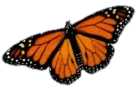

**Butterfly Weed**

*Asclepias tuberosa*

A free gift to you from the youth of

[Enter your church name]

**Planting Instructions**

**Important:**

Butterfly Weed seeds need 30 days of cold, moist temperatures (33 – 38 °F) before they will germinate. This is called stratification.

**Fall:**

Sow seeds directly outside. Cover with ⅛ to ¼ inch of soil. Seeds will be naturally stratified by cold temperatures and will germinate in spring.

**Spring:**

Mix seeds with an equal amount or more of damp vermiculite, or fold seeds into a damp paper towel. Store in a labeled, sealed plastic bag or container in the refrigerator (not freezer) for 30 days. Then sow outdoors as described above or start indoors in containers or soil blocks.

Milkweed sap is toxic to humans and livestock. It can damage eyes and irritate skin. Wash hands after handling leaves.

Cover illustration by Chester A. Reed [Public domain], via Wikimedia Commons

**Native Species**

Orange blooms with some red to yellow variation June-Aug

Needs at least half day of full sun & well drained soil

Drought tolerant and deer resistant

Average height 2 ft

Host plant for Monarch caterpillars and nectar plant for butterflies

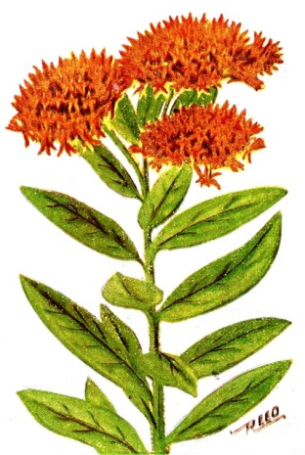

Seeds purchased from [enter seed source]

Packaged [enter date]

*Worthy are you, our Lord and God, to receive glory and honor and power, for you created all things, and by your will they existed and were created. Rev 4:11*



**Butterfly Weed**

*Asclepias tuberosa*

A free gift to you from the youth of

[Enter your church name]

**Planting Instructions**

**Important:**

Butterfly Weed seeds need 30 days of cold, moist temperatures (33 – 38 °F) before they will germinate. This is called stratification.

**Fall:**

Sow seeds directly outside. Cover with ⅛ to ¼ inch of soil. Seeds will be naturally stratified by cold temperatures and will germinate in spring.

**Spring:**

Mix seeds with an equal amount or more of damp vermiculite, or fold seeds into a damp paper towel. Store in a labeled, sealed plastic bag or container in the refrigerator (not freezer) for 30 days. Then sow outdoors as described above or start indoors in containers or soil blocks.

Milkweed sap is toxic to humans and livestock. It can damage eyes and irritate skin. Wash hands after handling leaves.

Cover illustration by Chester A. Reed [Public domain], via Wikimedia Commons

**Native Species**

Orange blooms with some red to yellow variation June-Aug

Needs at least half day of full sun & well drained soil

Drought tolerant and deer resistant

Average height 2 ft

Host plant for Monarch caterpillars and nectar plant for butterflies



Seeds purchased from [enter seed source]

Packaged [enter date]

*Worthy are you, our Lord and God, to receive glory and honor and power, for you created all things, and by your will they existed and were created. Rev 4:11*



**Common Milkweed**

*Asclepias syriaca*

A free gift to you from the youth of

[Enter your church name]

**Planting Instructions**

**Important:**

Common milkweed seeds need 30 days of cold, moist temperatures (33 – 38 °F) before they will germinate. This is called stratification.

**Fall:**

Sow seeds directly outside. Cover with ⅛ to ¼ inch of soil. Seeds will be naturally stratified by cold temperatures and will germinate in spring.

**Spring:**

Mix seeds with an equal amount or more of damp vermiculite, or fold seeds into a damp paper towel. Store in a labeled, sealed plastic bag or container in the refrigerator (not freezer) for 30 days. Then sow outdoors as described above or start indoors in containers or soil blocks.

Milkweed sap is toxic to humans and livestock. It can damage eyes and irritate skin. Wash hands after handling leaves.

Cover illustration by Zsoldos Márton, [Public domain], via Wikimedia Commons



**Native Species**

Pink blooms May-Aug

Needs at least half day of full sun & well drained soil

Drought tolerant and

deer resistant

Height 3-5 ft

Host plant for Monarch caterpillars and nectar plant for butterflies

Seeds purchased from [enter seed source]

Packaged [enter date]

Choose location with care. Spreads by runners and seeds.

*Worthy are you, our Lord and God, to receive glory and honor and power, for you created all things, and by your will they existed and were created. Rev 4:11*



**Common Milkweed**

*Asclepias syriaca*

A free gift to you from the youth of

[Enter your church name]

**Planting Instructions**

**Important:**

Common milkweed seeds need 30 days of cold, moist temperatures (33 – 38 °F) before they will germinate. This is called stratification.

**Fall:**

Sow seeds directly outside. Cover with ⅛ to ¼ inch of soil. Seeds will be naturally stratified by cold temperatures and will germinate in spring.

**Spring:**

Mix seeds with an equal amount or more of damp vermiculite, or fold seeds into a damp paper towel. Store in a labeled, sealed plastic bag or container in the refrigerator (not freezer) for 30 days. Then sow outdoors as described above or start indoors in containers or soil blocks.

Milkweed sap is toxic to humans and livestock. It can damage eyes and irritate skin. Wash hands after handling leaves.

Cover illustration by Zsoldos Márton, [Public domain], via Wikimedia Commons



**Native Species**

Pink blooms May-Aug

Needs at least half day of full sun & well drained soil

Drought tolerant and

deer resistant

Height 3-5 ft

Host plant for Monarch caterpillars and nectar plant for butterflies

Seeds purchased from [enter seed source]

Packaged [enter date]

Choose location with care. Spreads by runners and seeds.

*Worthy are you, our Lord and God, to receive glory and honor and power, for you created all things, and by your will they existed and were created. Rev 4:11*



**Showy Milkweed**

*Asclepias speciosa*

A free gift to you from the youth of

[Enter your church name]

**Planting Instructions**

**Important:**

Showy milkweed seeds need 30 days of cold, moist temperatures (33 – 38 °F) before they will germinate. This is called stratification.

**Fall:**

Sow seeds directly outside. Cover with ⅛ to ¼ inch of soil. Seeds will be naturally stratified by cold temperatures and will germinate in spring.

**Spring:**

Mix seeds with an equal amount or more of damp vermiculite, or fold seeds into a damp paper towel. Store in a labeled, sealed plastic bag or container in the refrigerator (not freezer) for 30 days. Then sow outdoors as described above or start indoors in containers or soil blocks.

Milkweed sap is toxic to humans and livestock. It can damage eyes and irritate skin. Wash hands after handling leaves.

Cover illustration by DL Pellegrin

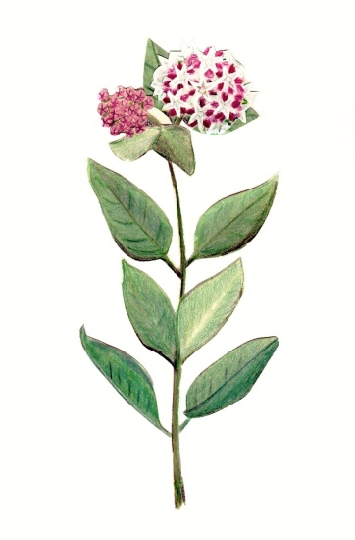

**Native Species**

Rose blooms May-Sept

Prefers full sun & well drained soil

Drought tolerant and deer resistant

Height 2-3 ft

Host plant for Monarch caterpillars and nectar plant for butterflies

Seeds purchased from [enter seed source]

Packaged [enter date]

Choose location with care. Spreads by runners and seeds.

.

*Worthy are you, our Lord and God, to receive glory and honor and power, for you created all things, and by your will they existed and were created. Rev 4:11*



**Showy Milkweed**

*Asclepias speciosa*

A free gift to you from the youth of

[Enter your church name]

**Planting Instructions**

**Important:**

Showy milkweed seeds need 30 days of cold, moist temperatures (33 – 38 °F) before they will germinate. This is called stratification.

**Fall:**

Sow seeds directly outside. Cover with ⅛ to ¼ inch of soil. Seeds will be naturally stratified by cold temperatures and will germinate in spring.

**Spring:**

Mix seeds with an equal amount or more of damp vermiculite, or fold seeds into a damp paper towel. Store in a labeled, sealed plastic bag or container in the refrigerator (not freezer) for 30 days. Then sow outdoors as described above or start indoors in containers or soil blocks.

Milkweed sap is toxic to humans and livestock. It can damage eyes and irritate skin. Wash hands after handling leaves.

Cover illustration by DL Pellegrin

**Native Species**

Rose blooms May-Sept

Prefers full sun & well drained soil

Drought tolerant and deer resistant

Height 2-3 ft

Host plant for Monarch caterpillars and nectar plant for butterflies

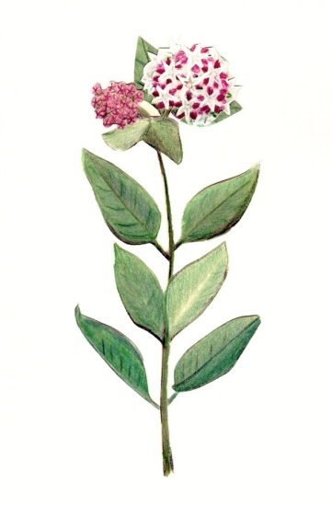

Seeds purchased from [enter seed source]

Packaged [enter date]

Choose location with care. Spreads by runners and seeds.

.

*Worthy are you, our Lord and God, to receive glory and honor and power, for you created all things, and by your will they existed and were created. Rev 4:11*